Statement about an attempting of arson on Shirak branch office of the
A.D.Sakharov human rights protecting center

07 | 07 | 2011 | 22:00 | statement

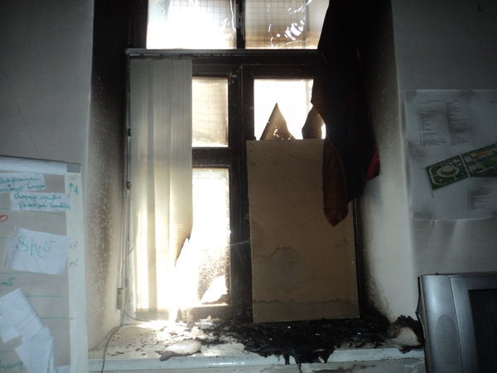
On July 6, 2011, in the morning at about 5 o’clock, some unknown persons broke the glass through metal bars Shirak branch Gyumri office window of the A.D.Sakharov Center for human rights protection in Armenia, and ignited the window and window path with liquid fuel. People living near the office saw the fire and called the fire service, they took their own measures to extinguish a fire after which the fire was extinguished. It was found out that significantly damaged some of the property of the office training hall and the hall as a whole, the repair cost of which exceeds 600,000 drams.

We all, undersigned organizations representatives of civil society express concern over the attack and arson connected to this, we condemn this attack and sauce of makers and implementers, noting that this is not the first time, when these methods are used for trying to intimidate or punish human rights protection defenders and non-governmental organization.
The police must make every effort to discover the direct doers and the men who ordered this crime, to ensure adequate publicity about the process of the case as soon as possible.

We urge the authorities to condemn such violence and to assist the Sakharov human rights organization and the office in Gyumri to continue its normal activity.

Hope that Sakharov human rights organization and the office in Gyumri will quickly overcome temporary difficulties, remaining so consistently in protection of human rights, as they have been for 15 years.

1. Journalists’ Club “Asparez”
2. “Shirak Centre” NGO
3. “Biosophia” NGO
4. “We Plus” Social NGO
5. “Khoran Ard” NGO
6. “Unison” NGO
7. “Arena of Education” NGO
8. Helsinki Citizens’ Assembly Vanadzor office,
9. “Rights Information Center” NGO
10. “Arevamanuk” Center for Children and adolescents care
11. Committee to Protect Freedom of Expression
12. Urban Foundation for Sustainable Development
13. Protection of Rights without Borders NGO
14. Yerevan Press Club
15. Community Initiatives and Advocacy Center NGO
16. “Victims of state needs” NGO
17. Transparency international anticorruption center
18. “Meghvik” NGO
19. Open Society Foundations-Armenia
20. “Full Life” NGO
21. Civil Society Institute NGO
22. “European integration” NGO
23. “Sacred land” BNGO
24. “Arax Center” BNGO
25. “Ani” disabled children NGO
26. Children society youth initiatives support center NGO
27. “Flora” Christian association of young women, NGO
28. “Azatan” community center of Azatan
29. “Million and half +1 Armenia Diaspora” Shirak Branch
30. “Agat” NGO, for women with special needs
31. “Likidon” art and moral-psychological development NGO
32. “Ajakic” NGO
33. “Leadership” NGO
34. “Health Center’’ rehabilitation NGO
35. “Aren” NGO
36. “Geophon” NGO
37. Gyumri young family supporting “Noyemi” NGO
38. “Gyumri development foundation” NGO
39. “Women developing center” NGO
40. “Gyumri Union of disabled people” NGO
41. “Guarantee” NGO
42. “Third Nature” NGO
43. “Fallen soldiers’ family” NGO
44. “Stability and progress” NGO
45. “Consultant” NGO
46. “Women for the future” NGO
47. “Women for the development” NGO
48. "Community Development and Social Support Center" NGO
49. “Armenian Karitas”
50. Armenia invalids “Pyunik” union Shirak branch NGO
51. “Meghvik” community development foundation NGO
52. “New generation” NGO
53. “Sirarpeni” NGO
54. "Gyumri progress" civil society development center
55. “Experimental cultural center” cultural analysis and development NGO
56. Goris Journalists’ club “Radius”
57. “Association of Women with University Education” NGO
58. “Aarhus center of Dilijan”
59. Ecotourism Association
60. City Researches Center
61. “Protection of consumers’ rights” NGO
62. Helsinki Committee of Armenia
63. Helsinki Association
64. “Yerevak” NGO
65. Community Union of Noyemberyan
66. Aarhus Center of Ijevan
67. «5th floor Art Group” NGO
68. "Center for Strategic Litigations" NGO
69. International Union of Black Sea NGOs (IUBS NGO)
70. Center for the Development of Civil Society
71. International Center of Human Development (ICHD),
72. Association "For Sustainable Human Development"
73. Martuwni Women`s Community Council NGO
74. Martuni youth institute
75. Zolaqar Women`s Council
76. N.Getashen Women`s Council
77. Lichq Women`s Council
78. Union of Armenian government employees UAGE
79. Foundation for Small and Medium Businesses

Other NGOs can to join this statement also

http://asparez.am/news/news2011july/07.07.2011-statement-sakharov-eng.htm

