 | 

Armenian Centre of Integration and Democracy

A.D. Sakharov Armenian Human Rights Centre

Research on determining the main factors of forming social capital in Yerevan, Gyumri and Gavar cities

This research was conducted with ideological and financial assistance of A. D. Sakharov Armenian Human Rights Centre

Content

Part 1. Project description

  - Preface
  - Methodology
Part 2. Analysis of the research results

Part 3. Summary /conclusion

Par 1. Project description

  - Preface

Social capital as a research subject is very important and complex. It allows understand the relations of society members, the presence or absence of which form their role, status and behaviour in the society.

There are different sociological approaches for the perception of social capital. Here are some of them:

James Coleman is one of the scientists, whose works contributed to wide circulation of the term “social capital” in scientific sphere. Coleman thought that the social capital is defined by the function made by itself. Robert Putnam defines the social capital as a characteristic of a social organization, which includes in it interaction norms, social networks and confidence, which make possible effective activity for gaining the common goal. Pierre Bourdieu has his contribution in the development of the concept of the social capital as well.

In the concept of Francis Fukuyama the social capital is viewed as a factor contributing to effective functioning of economy. That’s why the analysis of the social capital was implemented from social economical angle. By Fukuyama’s definition the social capital is the potential of the society or its part, which is formed in the result of confidence between its members. Confidence is defined as expectations created between the members of a group according to which the behaviour of each member is predictable and corresponding to several norms.

Fukuyama thought that the progress of the society in various spheres, particularly in economy, is conditioned by the level of confidence which make human relation predictable: the higher the level of confidence, the more effectively economy and society develop, as the relations of individuals are “stronger” in the social institute. According to Fukuyama, survival of human unions depends on confidence. Meanwhile, the concept of confidence in its turn is conditioned by culture. Thus, in different cultures there are different types of confidence-individual, institutional and generalized [Fukuyama 51, 2006]. Social capital differs from other capitals by the fact that it is created and transferred through cultural mechanisms, such as religion, traditions and customs. Social capital is formed due to authority, which forms definite norms and values, general samples of behavior for subordinates. Afterwards, in the result of socialization such norms and values are transferred from generation to generation, and over the time are transformed into traditions/customs. In the result, behavior models are developed which contribute to formation of collaboration and high level of confidence in the society, which, in its turn, promotes the development of different spheres of society, particularly the economy.

Fukuyama’s concept is the basis of our research.

B) Research description
The aim of the research was to assess the criteria of the social capital which in the studies are characterized as macro-level of the social capital.

This research allowed raise and analyze the factors which have influence on the formation of the social capital. As the social capital is a broad concept, as a base we took interpersonal relations (level of confidence, social activity, etc.), group identity, including the level of civil identity, level of interpersonal tolerance, as well as the level of tolerance towards other groups, other mentality and religion.
The research target was the population in Yerevan, Gyumri and Gavar.
The objective of the research was to determine the level of impact of cultural, ethical, social-psychological, spiritual and religious factors among different segments of the population-mutual confidence, identity, tolerance, participation, etc.

C) Methodology
For conducting the research qualitative and quantitative methodology has been used. Focus-group discussion was chosen as a qualitative research method, which allowed to study the issue more deeply and to reveal the peculiarities of the factors which form the social capital in our society. A discussion guide was developed.

For implementing the quantitative research face to face interviews were conducted.

For getting representative results we took gender, age, education and employment of respondents as bases. That means we have applied quota sampling. This allowed reveal links, e.g. the level of confidence towards higher education and authorities.

Part 2. Analysis of the research results

Quantitative research was conducted in the cities of Yerevan, Gyumri and Gavar. In total 240 people were interviewed – 120 in Yerevan, 75 in Gyumri, 45 in Gavar and 35 in Goris. The sampling allowed to compare the data according to cities taking into account the number of the population.

Diagram 1. Number of respondents by cities

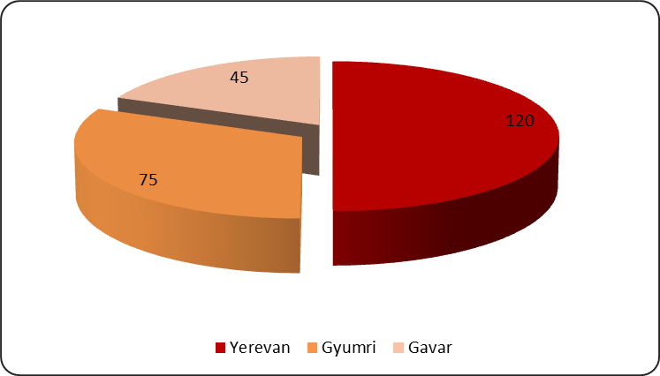

For determining the degree of confidence towards people we asked our respondents, “Can the majority of people be trusted?” By the way, this question is applied almost in all research works of the social capital, and its formulation is selected for comparing the results in comparative research works.

Diagram 2. “Can the majority of people be trusted?”

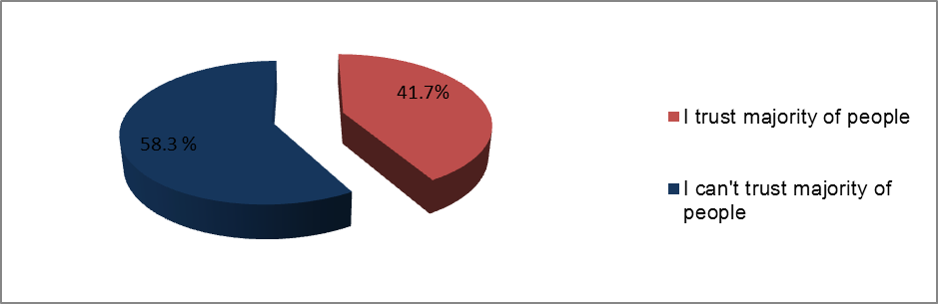

41.7% of the respondents mentioned that they trust the majority of people. In Yerevan and Gyumri this figure was slightly higher-44.2% and 46.7% respectively, in contrast to Gavar- 26.7%. Women and men have the same degree of confidence.

We tried to determine the degree of citizens’ confidence in interpersonal relations and towards different structures. As expected, relatives and family members enjoy very high confidence among the respondents-95.1%. The respondents share the personal and business events taking place in their life with their relatives and family members. The next are friends whom trust the 75.8% of the respondents. The 36.2% of the respondents trust their colleagues, and 30.4 % trust their neighbours and even 62.1% of the respondents will trust the keys to their houses to their neighbours. In Gyumri their percentage is the highest-73.3%.

Diagram 3. In case of need, will you leave your house key to your neighbour?

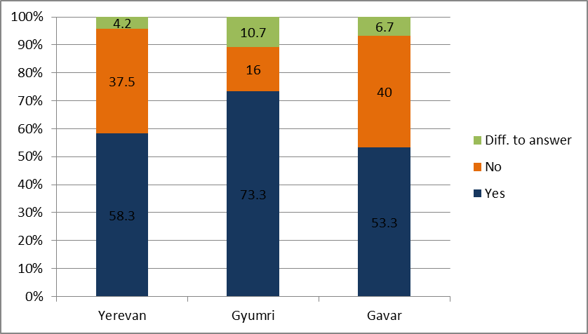

Half of the respondents mentioned that they don’t trust strangers, and only 6.7% mentioned that they trust them. However, to the question “Will you help a stranger if in the street he/she asks to use your cellphone”, the 77.5% of the respondents answered “Yes”.

Diagram 4. Degree of confidence
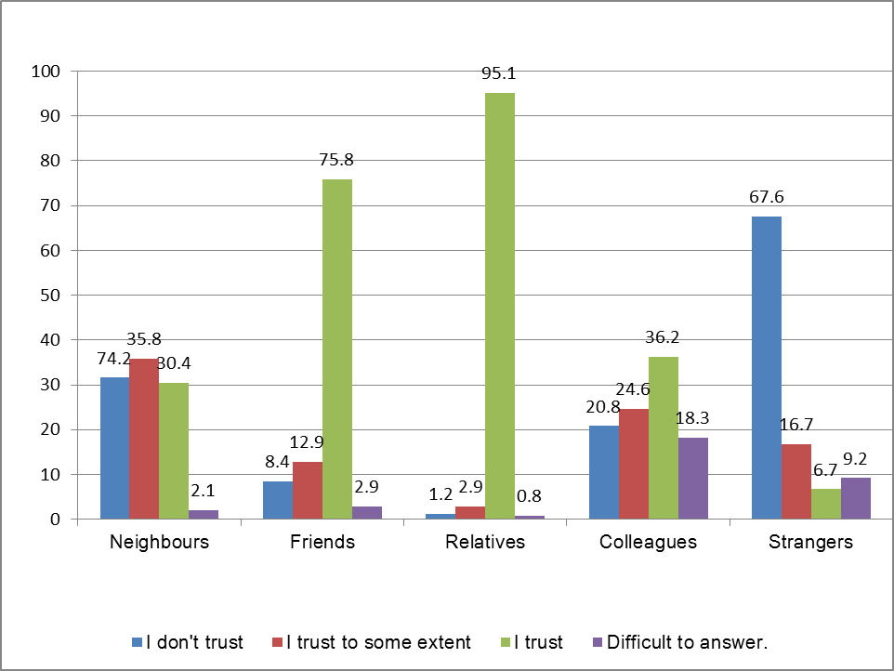
20.8

During the research the degree of confidence of our society towards the president and prime-minister, the government, printed and online mass media and its attitude towards the elections became evident.

Here we have too low level of confidence towards the authorities and the government. The same is with the opposition powers. This, in general, speaks about low confidence towards all the power structures functioning in the political field of our society. :

The picture is not encouraging in terms of confidence towards mass media. Printed and online mass media are trusted 8.8% and 10.5% correspondingly by the respondents, and TV-12.9%.

Benevolent organizations are trusted 25.9% and private donors 37.1 by the respondents.

Generally, the level of confidence towards the government and mass media of the country speaks about the low level of social capital in that country. In this case people begin to associate their goals and desires with miracles or other phenomena. As we saw the level of confidence towards the above mentioned structures is rather low, and to the question- “Do you believe in paranormal phenomena and miracles?” the majority of the respondents answered positively. The 59.6% of the respondents mentioned that they believed, the 23.8% that they didn’t and 16.7% found it difficult to answer.
During a group discussion we tried to find out why we believe and why we don’t, whether we could speak about the loss of confidence and by what it could be conditioned. As one of the reasons the current social and economic situation was mentioned, which is getting worse and this is the reason that people are more careful and don’t trust each other.

One of the quantitative indicators of the social capital is the number of contacts. The results of the research show that in a small town like Gavar the number of people having more than 200 contacts in their cellphones exceeds the indicator of Gyumri and Yerevan.

Diagram 5. How many telephone numbers are there in your cellphone?

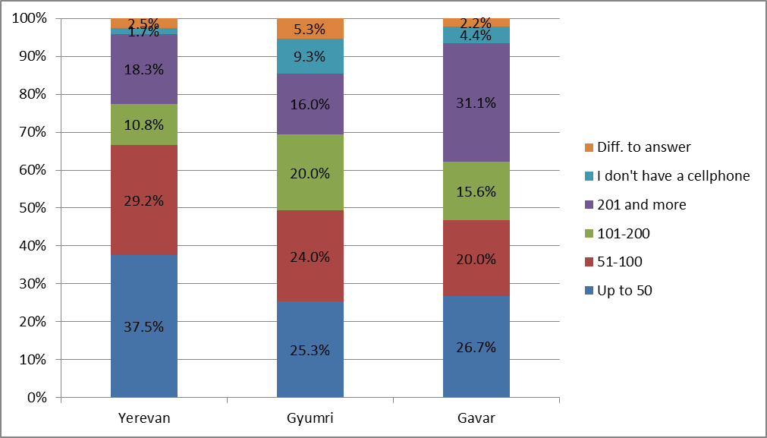
Here we can make two suppositions: in Yerevan the number of social networks users is greater, and those contacts replace telephone contacts. The other explanation is that the smaller is a town, the better people know each other and the more intensive are their relations.

Another quantitative indicator which characterizes the intensity of social relations is the participation in events like weddings, christenings and funerals. This indicator is rather high.

Diagram 6. How many times did you participate in various events in the course of the last year?

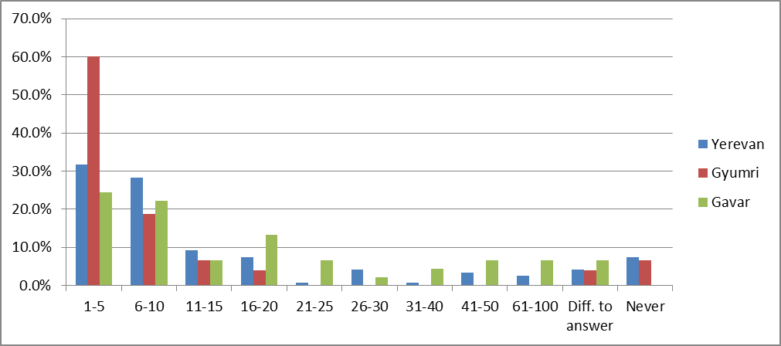
Confidence and money
Speaking about money and confidence, one of the participants of the discussion mentioned that in our culture, opposite the European one, money is not separated from the frame of confidence and doesn’t become a subject of practical relations. The majority of our respondents lent and borrowed money. As it became clear from the results of the group discussion, there is no practice of signing contract or other document between friends and acquaintances while lending money. It’s done only on the basis of mutual confidence.

During the discussion we found out how many people and who could lend money, e.g. 30.000 AMD by making only one call. As it turned out in all the cases there were 2-5 people whom our respondents trusted most. Only one respondent assured that about 200 people from his friends could lend him money.

The comparative intensity of the communication is represented in Diagram 8. The values are written in percent.

Diagram 7

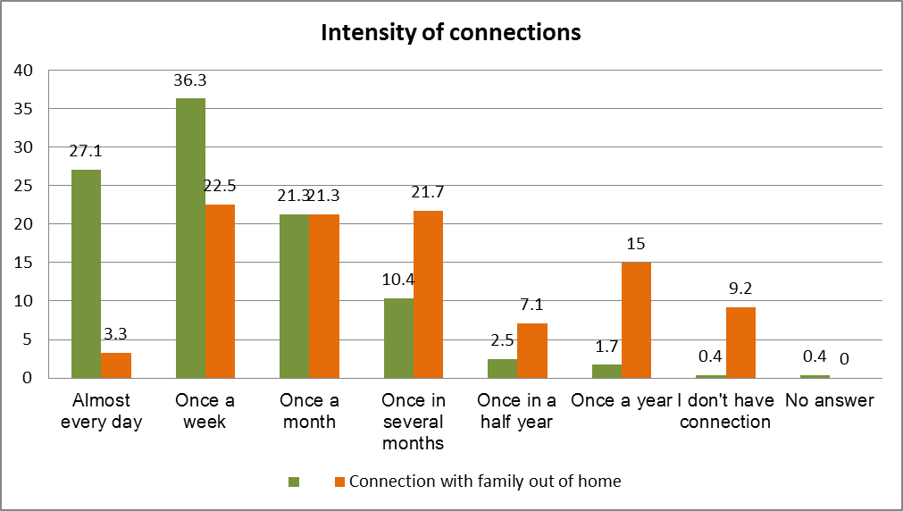
Quite many respondents (31.3%) have extremely rare or no relations with their family members.

By speaking about money and confidence, it’s important to know which the maximum amount is that the respondents are ready to lend to their neighbor. The same question is in case of friends. For being able to make comparison we tried to find out which was the minimum amount of money people should have in their wallets for felling themselves confident and comfortable.

Diagram 8

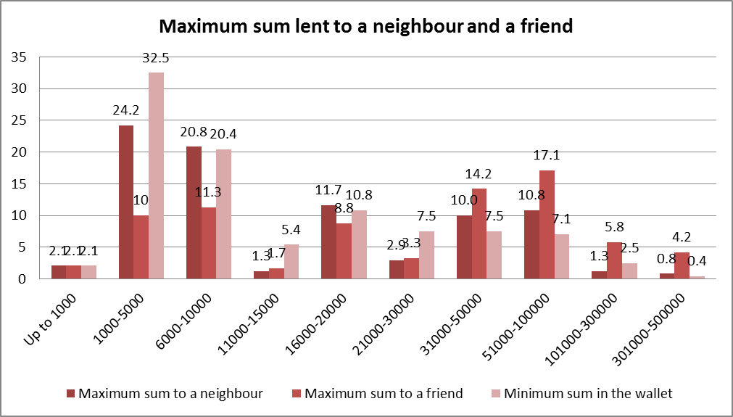
During the group discussions one the participants mentioned that by deciding how much money one was ready to lend, he/she decided for himself/herself how much money he/she was ready to lose. It means that it’s the sum that even in case of losing it forever one will not suffer too much.

Civil involvement

During the research it was necessary to find out the extent to which our citizens were involved in the civil life and how much importance they attach to their role as citizens.

We suggested the respondents to choose one from two formulations which more exactly expressed their attitude towards elections.
The first one was “We elect a leader through elections” and the second one “Election bear formal nature, and only people chosen beforehand come to power”.

Thus, the majority of the respondents-91.3% considers that elections bear formal nature, however rather high percent of the respondents consider their participation in elections necessary. In Gyumri this indicator is the highest, which is conditioned by the result of the last presidential elections, when opposition won in Gyumri.

Diagram 9. How important is your participation in elections?

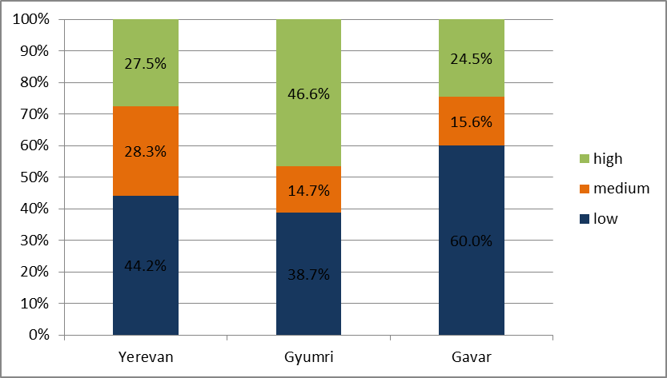
All the participants of the discussion mention that they take part in elections. Although they mention that they don’t trust our government and authorities at all.

Regarding ideology of the political parties, during the discussion it was mentioned that they are similar. Few of the participants have idea about the ideology of the parties. Their low level of awareness is directly connected with low level of confidence towards the political parties. As the participants mentioned “The same words are written in the election programmes of the parties, only in different lines”.

It’s rather interesting that the majority of the respondents only have little idea about the ideology of the parties functioning in Armenia, or they have no idea at all.

Diagram 10. Do you have idea about the ideology of the parties functioning in Armenia?

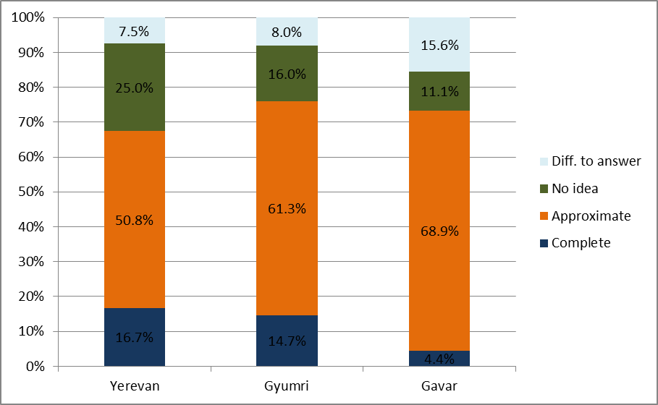

The question “Is there a party whose ideology you share” had the same results.

Diagram 11. Is there a power or party whose ideology you share?

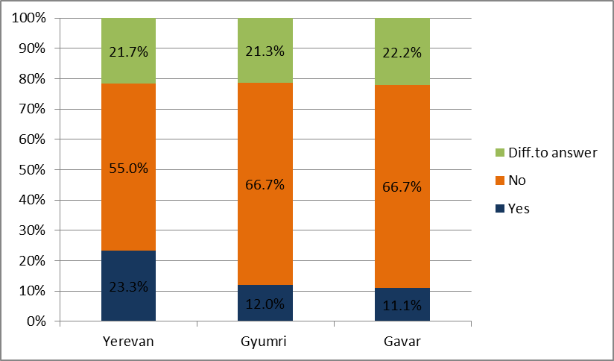

Social involvement
One of the components of the social capital is the participation in civil society structures, which aims at solving any universal problem-environmental or monitoring of elections processes.

The results of the research showed that this kind of involvement is not big. The negligible part of the respondents is a member of a volunteer union.

At the same time the 80.8% of the respondents mentioned that they had implemented volunteer unpaid work, and the 90.8% mentioned that they helped strangers by giving them money, clothes and food.

This also speaks about the low level of confidence, as the members of a society, which have many problems, should have big tendency of getting united.

Tolerance
As we mentioned in the preface, according to Fukuyama the social capital is created and transferred through religion as well. That’s why it’s important to study religious preferences, habits and goals of going to church.

Absolute majority of the respondents answered that they believe in God-90.8%, only 2.9% of them don’t believe in God and the rest 6.3% found it difficult to answer. It’s worth mentioning that we had the same picture in all the selected regions.

Diagram 12.
The majority of the discussion mentioned that they believed in God, except one person, who was an atheist.

The participants pray everywhere. One of them even has an icon with him. For the participants the faith is one of the most important stimuli to live. One of the participants mentioned that though some people, especially atheists, consider Christianity an anti-intellectual religion, it’s not true.

I think Christianity is one of the most intellectual religions. [Female, 34 years old, a lecturer].

Regarding the frequency of attending church, few of the respondents go to church every day - 4.2% and the 2.5% never go. The 32.9% go to church once in a month, the 30.4% more seldom, and the 30% once in a week. It’s interesting to note that the last 3 answers are quite close to each other in percent terms.
Although the participants of the discussion believe in God, they don’t connect their faith closely with the church.
There were participants who mentioned that they go to church every Sunday for liturgies, or, if not often, then several times a month.

Although it’s difficult, I try to follow the commandments. [Male, 37 years old, a, novelist].

The others go to church more seldom. Mainly they go to church on certain occasions, for having spiritual rest, some for taking part in a liturgy. The participants think that it’s not necessary to go to church to get your prayers to God.

They say that the church is God’s house, but I think there shouldn’t be any mediator between me and God. I pray at home. [Male, 43 years old, a political scientist].

I mainly go to church for having rest, as the atmosphere there is excellent. [Female, 36 years old, a teacher].

To the question why the respondents go to church, they answered the following: for praying-39.6%, for lighting a candle-25.8%, for different occasions-10.4%, by custom-10% and for getting blessing-7.5%.

The overwhelming majority of the respondents in three regions mention that they are followers of Armenian Apostolic Church-60.8%. Some of them mention that they are just Christians- 25.4%. There were other answers, such as “I believe in God”-2,9%, “I’m an atheist”-2,1%, and “I don’t belong to any religion”-1,7%, etc.

We tried to find out what people expect by following any religious direction. It was interesting to find out, whether the respondents considered themselves a part of a certain religious community and how it affects their everyday life and on formation of the social capital.
We suggested several variants of answers, which we thought could properly describe their senses and material achievements as a part of a certain religious community.

The percent ratio of the answers is represented below:
Chart 1
Does following the mentioned religion give you:
 | Confidence | Spiritual rest | Sense of security | Financial assistance | Relations | Opportunity to be useful | Sense of being required
Yes | 60% | 80.4% | 49.2% | 4.2% | 7.1% | 35.8% | 27.1%
NO | 40% | 19.6% | 50.8% | 95.8% | 92.9% | 64.2% | 72.9%

This ratio is seen also according to regions. As we see from the chart following any religion gives the respondents more spiritual than material assistance. Thus, the majority of the respondents mentioned that religion gives them spiritual rest- 80․4%, the 60% mentioned that it gives them confidence and only the 4.2% mentioned that it gave them financial assistance and the 7.1%-relations. Almost half of the respondents mentioned that they feel secure by following their religion. Most of them feel themselves useful while helping other people-35.8%.

From here we can conclude that the following of a religion doesn’t play a great role in the formation of the social capital in the cities selected for the research.

Confidence and tolerance are in the basis of the social capital. Tolerance plays a big role in different social institutes and in the relations of separate people. It was interesting to study the population’s level of confidence and attitude towards different religions and religious structures, ethnic minorities and Armenians coming from other countries.

Religion is one of the most important factors for forming relations in the society, and it greatly affects the level of the social capital. We can state, that the number of people following other religions is not big, and the number of followers of Armenian Apostolic Church is the overwhelming majority. But the number of sectarians is rather high in Armenia. Thus it’s necessary to study the attitude and the level of tolerance towards different religions and religious structures.

The majority of the respondents have positive attitude towards the followers of Armenian Apostolic Church-73.3%, the followers of Orthodox and Catholic churches (which are Christian denominations)-45.4% and 37.5% correspondingly. However many people have both positive and negative attitude towards the followers of Catholic church-24.2%.
The attitude towards the followers of Protestant church is more negative than positive: very negative-34.2% and more negative-4.2%.

More negative attitude the respondents have towards the followers of Islam-51.2% and Buddhism-42.1%. But in these two cases there were many answers “It’s difficult to answer”- 15% and 17.1%.

It’s interesting to note that the most negative attitude the respondents have towards the followers of other religious structures-80.8%, such as Jehovah's Witnesses, Pentecostals, etc. The respondents assessed using a 1-5 scale, where 1 is the most negative and 5 is the most positive assessments.

Percentage is represented in Chart 2 according to the regions.
Attitude towards the followers of other religious structures
 | 1 | 2 | 3 | 4 | 5 | Difficult to answer
Yerevan | 89.2% | 4.2% | 1.7% | 0.8% | 0.8% | 3.3%
Gyumri | 72.0% | 2.7% | 5.3% | 1.3% | 4.0% | 14.7%
Gavar | 73.3% | 2.2% | 0.0% | 0.0% | 2.2% | 22.2%

As we see, many people in Gyumri and Gavar found it difficult to answer. From here we can conclude that the population of the selected regions have very positive attitude towards Armenian Apostolic Church, but the same can’t be stated about other religions and religious structures.

In the result of the research we found out that the people in the selected regions are tolerant enough towards followers of other religions, however, they prefer to have relations with followers of the same religion. Thus, the 36,3% of the respondents mention that they can have relations with followers of any religion, the 35,8% of them want to have relations with followers of their religion, the 10,4% don’t want to have relations with followers of other religions and the 17,5% of them don’t want their children to have relations with followers of other religions, The picture is almost the same in three regions.

The majority of the participants of the discussion mention that in business relations they see no problem in having relations with followers of other religions. They trust them in work until there is mutual respect between them. The participants see no problem until the followers of other religions begin preaching.

Regarding marriage, majority of people are against marrying followers of other religions, paricularly muslims. They are not against marriages with follwers of other Christian religions such as followers of Catholic and Orthodox churches.

I'll persuade my child not to marry with a follower of other religions, particularly with a muslim. [Female, 34 years old, a lecturer.]

Some of the participants are intolerant towards sexual minorities. In any case they don't show heir attitude obviously and don't show discrimination, for instance at work. According to them this can turn into a national survival issue for a small country like Armenia. Soem of the participants are more tolerant until they bother them with their sexual issues. They think that these people have equal rights, however, this phenomenon contradicts Christianity and their upbringing.

We got very different opinions about ethnic minorities. The 35% of the respondents mention that they have negative attitude towards ethnic minorities, the 26.3%-more poitive attitude. In this question 1-5 points scale was used as well, where 1 is the most negative nad 5 is the best assessment. The percentage according to the regions is represented in the chart below:

Chart 3
Attitude towards ethnic minorities
 | 1 | 2 | 3 | 4 | 5 | Difficult to answer
Yerevan | 39.2% | 10.8% | 18.3% | 12.5% | 10.0% | 9.2%
Gyumri | 32.0% | 8.0% | 16.0% | 16.0% | 14.7% | 13.3%
Gavar | 28.9% | 2.2% | 20.0% | 15.6% | 13.3% | 20.0%

The participants of the discussion mainly have positive attitude towards foreigners who live in Armenia as long as they respect our culture and traditions.

It’s ok that foreigners live in Armenia, but they must be minorities so that the demographic description of our nation will not change. [Female, 36 years old, a teacher].

Regarding the Armenians coming from other countries our participants have very positive attitude, especially towards Syrian Armenians, as they are very honest and hard-working.

I think it’s a great advantage that these people, especially Syrian Armenians live in our country, as they change the atmosphere of our country. [Female, 26 years old, a journalist].

The respondents are tolerant enough towards other nations which constantly or temporary live in Armenia. The majority mention that their attitude is neutral-42,5%, the 32,5%-is positive and the 20,8%-very positive, and only 2,5% have negative attitude. The attitude towards Armenians coming from other countries is slightly different. Thus, the 42,5% of the respondents have positive, the 40,4%-very positive, the 14,6%-neutral and the 1,3%-negative attitude towards them. This is rather good potential for strengthening the social capital.

However, the majority of the respondents mention, that the above mentioned have other cultural values.

Chart 4
Do you think they have other cultural values than Armenian living in Armenia?
 | They have completely different cultural values | Their cultural values to some extent vary from our values | They have almost the same cultural values
Yerevan | 7.5% | 70.0% | 22.5%
Gyumri | 8.0% | 60.0% | 32.0%
Gavar | 26.7% | 46.7% | 26.7%

Volunteer work also can be viewed as a factor of forming the social capital. The overwhelming majority of the respondents mention that they have implemented volunteer work-80,8% and only the 19,2% gave a negative response. From here we can conclude that there is rather big potential for raising the level of the social capital in the selected cities.

Involvement of people in different social institutes and their relations also speak about low or high level of the social capital. The level of involvement of the respondents vin different social institutes and initiatives is low enough. Only 13.3% of the respondents mention that they are members of parents’ councils.

Chart 5
Do you a member of …?
 | Parents’ councils at schools | Environmental organizations | Children’s rights organizations | Sport clubs | Religious organizations | Trade unions | other
Yes | 13․3% | 10.0% | 7.1% | 9.6% | 3.3% | 12.1% | 4.6%
No | 86.7% | 90.0% | 92.9% | 90.4% | 96.7% | 87.9% | 95.4%

The level of the respondents’ involvement in public movements/initiatives is low as well. The 29.6% mention that they took part personally, the 14․2%-took part through social networks and the 59․2%-didn’t take part at all.

Here are the answers according to the regions:

Diagram 13

The participants of the discussion notice that recently citizens have been more active. They are also active in civil initiatives, but most of them think that it’s not necessary to take part in them personally, but they can do it through social networks and petitions. The last one works well in the civilized world and brings more serious results than standing and shouting in the crowd.

We must come to the establishment of petition institute in Armenia and development of online democracy. [Male, 43 years old, political scientist].

To the question “In which case you will go out of your house for fighting”, many of the participants mention that they will join the movements not only virtually, but physically as well and will fight, if the issue concerns concession of Karabagh territories and endangering the church.

There are opinions that the role of social media and electronic democracy is very great in the establishment of civil society, but it should not be limited by this.

Some of the participants think that it’s necessary to participate in the events taking place in the country and in decision making processes. Citizens can have impact but in our country, but all this takes place very slowly in our country.

By fighting for a long period of time you understand how powerless you are. [Female, 26 years old, a journalist].

The participants mainly take part in spontaneous actions, e.g. against increase of transport fees. They are skeptical towards the initiatives that are planned in advance, because there are always other interests behind them, and they are financed from abroad.

Participants of civil initiatives have taken part with their friends, and some of them even obtained new friends. We can conclude that such initiatives speak about comparatively high level of the social capital.

We also tried to find out whether the participants of the discussion are devoted to companies/organizations where they work and whether they consider themselves a part of their organization. Relations, atmosphere and devotion at work depend on several circumstances. For instance, as mentioned during the discussion, sometimes there is generations’ conflict at work: elder people hinder the work of the young ones. This demotivates young people. One of the participants mentions that his colleagues are from one family. But this not acceptable as in this case:

Father can say: “Ok, my son, you can work not properly and I will pretend I don’t see it ”. [Female, 26 years old, a journalist].

It’s interesting that in many cases employers call their working team a family, which brings its negative consequences. One might suppose that employers, considering the family the most important and effective social institute, try to create similar atmosphere at workplace. This causes unhealthy relations in the workplace. According to the participants working relations should be formed at workplace, where each member of the work team knows his responsibilities.
Devotion greatly depends on human factor. There are many people who get very low salary but are devoted to their work. These people simply love their work and receive spiritual satisfaction.

There is also the opposite phenomenon: there are people who get very high salary but think of changing their work for getting even higher salary.

A person, regardless of his/her position, should understand where he/she works, which are the goals and mission of the organization. This is the most important thing. For instance in Grand Candy even a worker of the lowest levels will put you on your place if you say something negative about the company. [Male, 43 years old, a political scientist].

We can conclude that mutually beneficial conditions motivate people to be devoted to their companies, which also play a role in the formation of the social capital.

Part 3. Summary

The level of interpersonal confidence is rather high in our society. People trust their neighbours by leaving the keys to their houses, trust their cellphones to strangers. At the same time it’s very low towards authorities, government institutes and companies, as well as towards mass media. Even the confidence towards private beneficiaries is higher than towards benevolent organizations.

Let’s remind you that F. Fukuyama suggested the concept of “radius of trust” by proving that the effectiveness of a country’s economy depends on the radius of trust of the given society: if it’s small, as in the case of our research, that is it’s limited by the most close people-relatives, family members, then economic relations are not so effective than they could be. We greatly trust only 2-4 people-sisters, brothers, spouses and other relatives.

In the selected cities the absolute majority of the respondents are followers of Armenian Apostolic Church. Religion has great impact on the level of tolerance in the society. The level of confidence is high towards different denominations of Christianity such as Catholic Church, Orthodox Church. To some extent people are tolerant towards followers of other religions, although the population’s awareness level on other religions is low. They are extremely intolerant towards the followers of various religious organizations, who are considered as sectarians.

Attitude towards other nations is more positive as long as they respect our culture and traditions. In working relations the attitude is very positive and there is no discrimination. Regarding marriage it’s negative. Attitude towards Armenians coming from other countries is positive, but there is an opinion that they are bearers of other culture and customs. Form here we can suppose that the level of tolerance is rather high and greatly conditioned by following religions.

Social involvement has a situational nature. Especially young and middle aged people respond to various social issues. By being united they form very effectively operating network in Facebook by giving others the opportunity to join and participate in the struggle. Almost nobody remains impartial to this type of social collaboration. These groups stop their activities as soon as the issue is solved.

Many people take part and support such initiatives, but new links are not created from those groups, and even they are created, the intensity of communication remains low.

